**LAPORAN HASIL TEORI**

**ALGORITMA STRUKTUR DATA**

**TREE**



**Oleh:**

**FAUZIYYAH ADELIA RAMANDA**

**NIM. 2341760145**

**SIB-1F / 10**

**D-IV SISTEM INFORMASI BISNIS**

**JURUSAN TEKNOLOGI INFORMASI**

**POLITEKNIK NEGERI MALANG**

**Latihan 1**

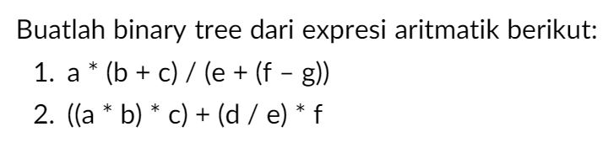

1. 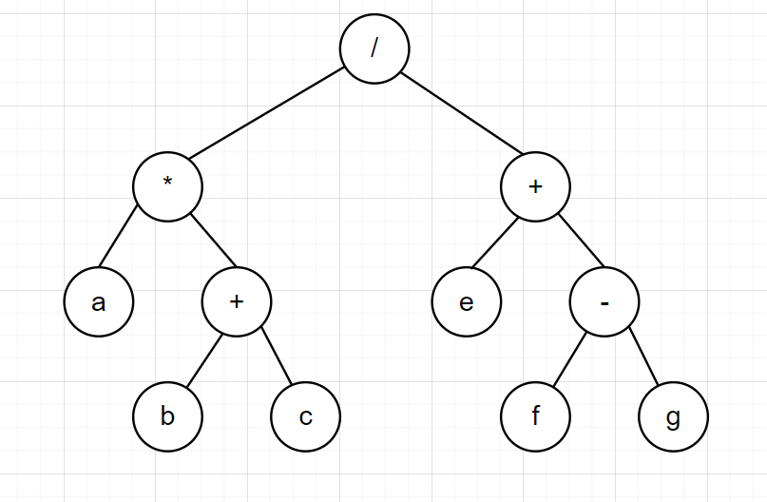 2. 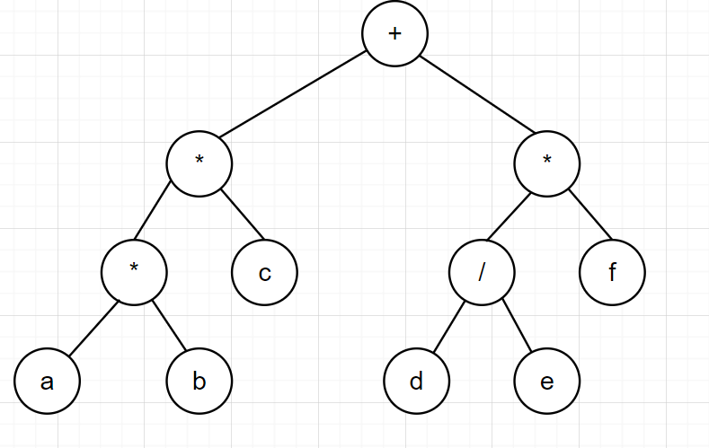

**Latihan 2**

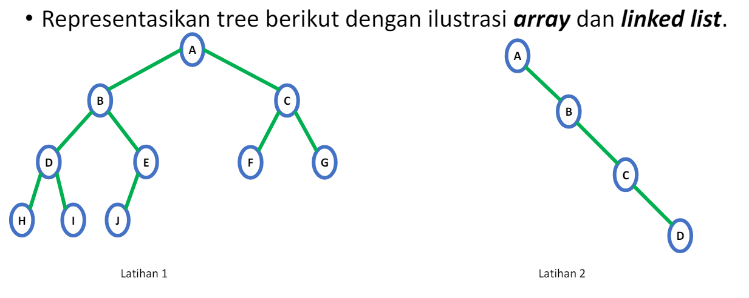

1. Ilustrasi array

|  |  |  |  |  |  |  |  |  |  |  |  |  |  |  |
| --- | --- | --- | --- | --- | --- | --- | --- | --- | --- | --- | --- | --- | --- | --- |
| A | B | C | D | E | F | G | H | I | J |  |  |  |  |  |
| 1 | 2 | 3 | 4 | 5 | 6 | 7 | 8 | 9 | 10 | 11 | 12 | 13 | 14 | 15 |

Ilustrasi Linked List

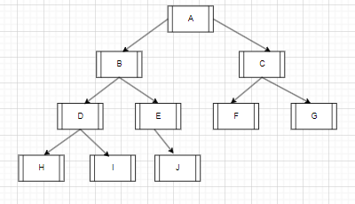

1. Ilustrasi array

|  |  |  |  |  |  |  |  |  |  |  |  |  |  |  |
| --- | --- | --- | --- | --- | --- | --- | --- | --- | --- | --- | --- | --- | --- | --- |
| A |  | B |  |  |  | C |  |  |  |  |  |  |  | D |
| 1 | 2 | 3 | 4 | 5 | 6 | 7 | 8 | 9 | 10 | 11 | 12 | 13 | 14 | 15 |

Ilustrasi Linked List

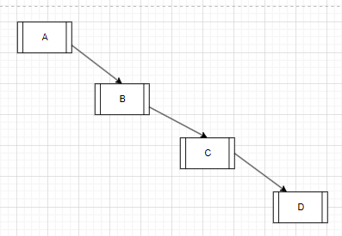

**Latihan 3**

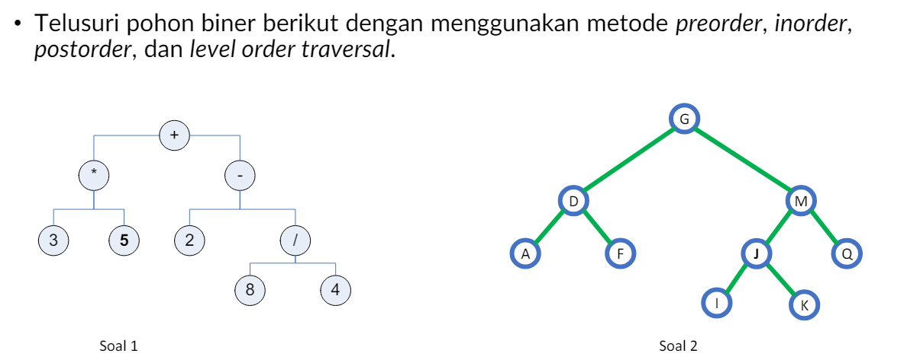

Soal 1

Preorder = +, *,3,5,-,2,/,8,4

Inorder = 3, *, 5, +, 2, -, 8, / , 4

PostOrder = 3, 5, *, 2, 8, 4, /, -, +

LevelOrder = +, *, -, 3, 5, 2, /, 8, 4

Soal 2

PreOrder = G, D, A, F , J, I, K, Q

InOrder = A, D, F, G, I, J, K, M , Q

PostOrder = A, F, D, I, K, J, Q, M, G

LevewlOrder = G, D, M, A, F, J, Q, I, K

**Latihan 4**

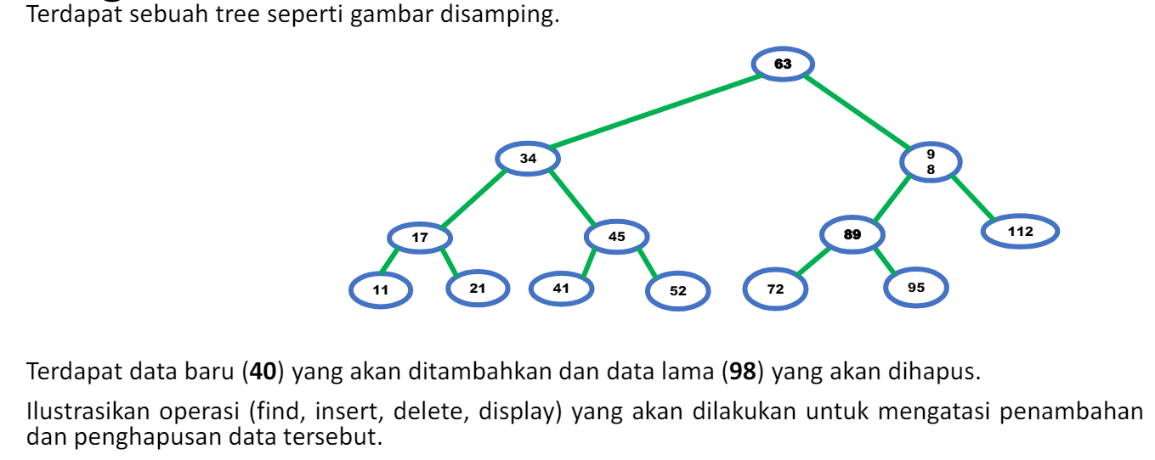

Display

Preorder = 63, 34, 17, 11, 21, 45, 52, 98, 89, 72, 95, 112

InOrder = 11, 17, 21, 34, 41, 45, 52, 63, 72, 89, 95, 98, 112

PostOrder = 11, 21, 17, 41, 52, 45, 34, 72, 95, 89, 112, 98, 63

LevelOrder = 63, 34, 98, 17, 45, 89, 112, 11, 21, 41, 52, 72, 95

